Assignment 3: Understanding Algorithm Efficiency and Scalability

Student Name
University
2025 Fall - Algorithms and Data Structures (MSCS-532-B01) - Second Bi-term
Professor Name
November 03, 2025

Introduction
Computational problems can be effectively solved by using efficient algorithms, whose time complexity and scalability must be learned. Randomized Quicksort is a divide-and-conquer algorithm that maximizes the sorting time and picks a random pivot. Chaining with Hashing is another important algorithm to deal with key-value pairs, which provides efficient search, add, and delete functions. Through the study of the average-case time complexity of the Randomized Quicksort and the performance of hash functions, including the effects of load factors, much can be learned about how to optimize the performance of an algorithm as well as reduce the number of collisions.

Part 1: Randomized Quicksort Analysis
1. Implementation
The randomized Quicksort algorithm chooses a randomized pivot of the subarray and shifts it to the end, which is simpler to divide. Replacing the elements around the pivot will be such that smaller elements are shifted to the left and bigger elements to the right. The time-consuming process ends when the left and right subarrays are recursively sorted until the entire array is sorted. Treatment of edge cases like empty arrays, sorted arrays, and repetition are treated and makes the algorithm robust.
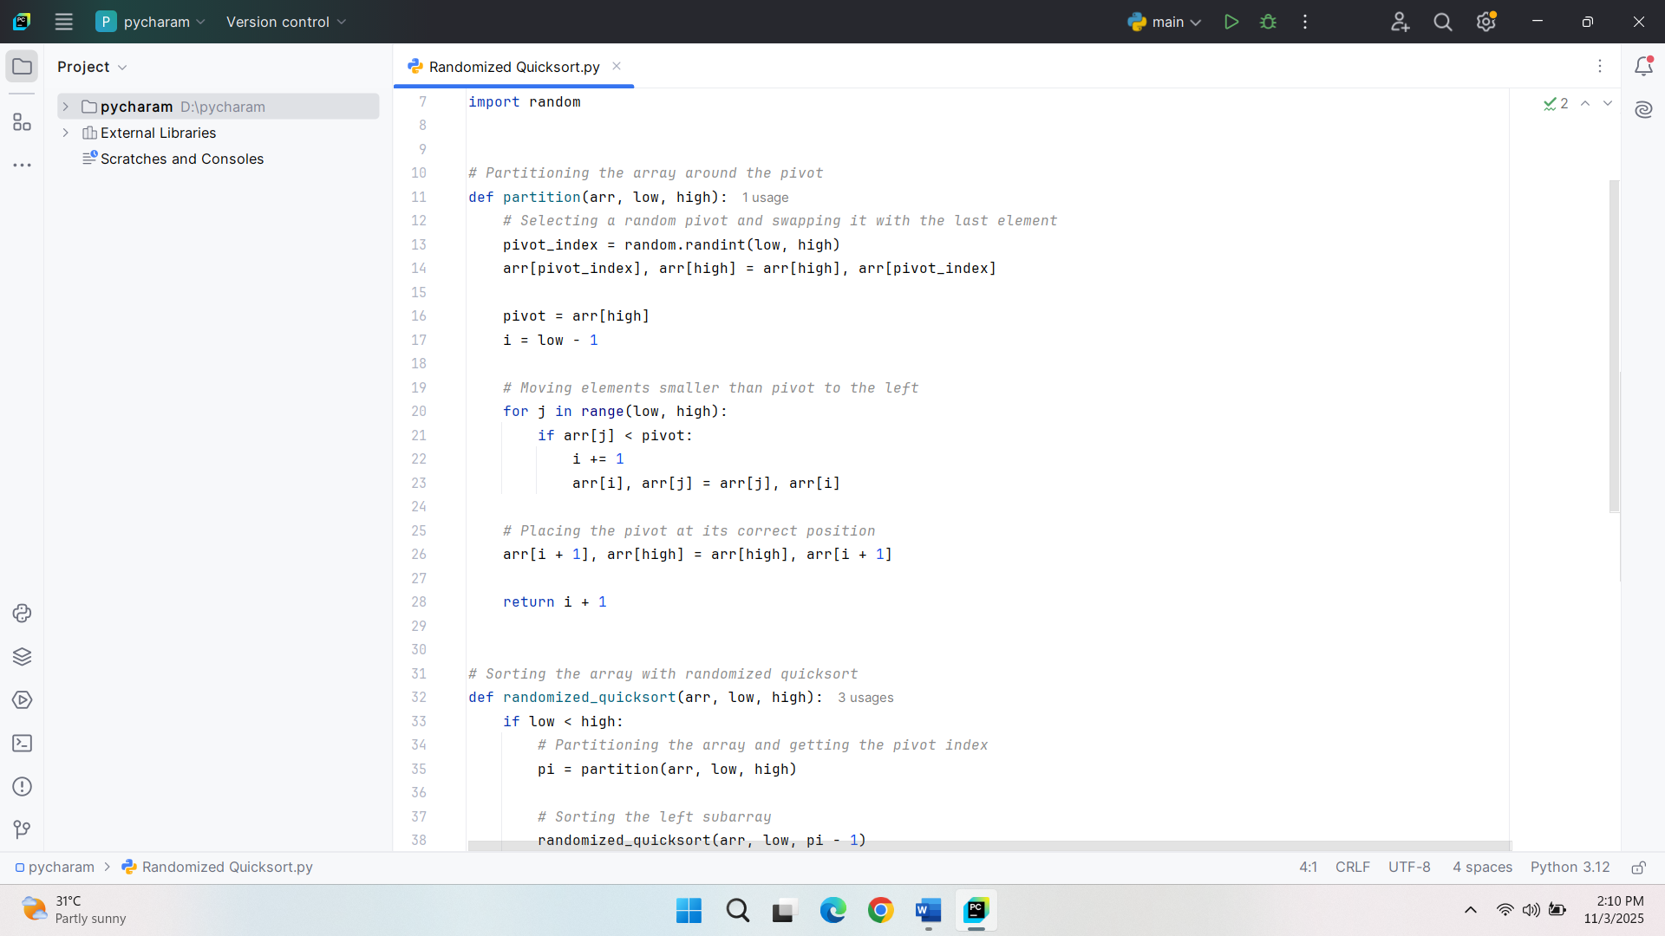
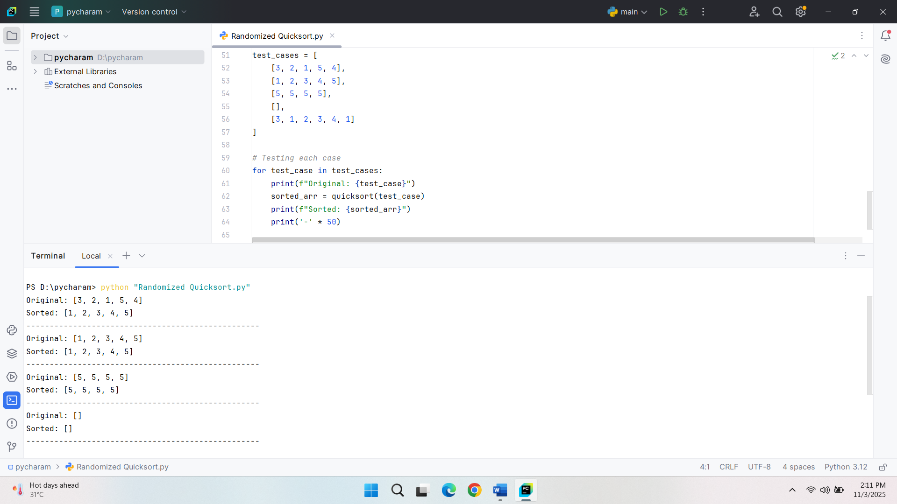
2. Analysis
Randomized Quicksort Time Complexity on Average Cases
The average case time complexity of randomized Quicksort is O (nlogn). Through the random choice of the pivot, it is due to this that, on average, the array is divided into two equal subarrays. The trick in this analysis lies in the number of comparisons that are likely to be performed in a partitioning process, and this is proportional to n. The size of a subarray that is processed in each recursive call is about half the size of the one in the previous recursive call, resulting in a logarithmic depth of recursion (Mohammadagha, 2025). Because at every level of recursion, the elements processed are n and the recursion depth of the recursion is O(logn), the time complexity of the recursion is O(nlogn).
Average Case Time Complexity
On average case basis, time complexity O(nlogn) can be explained by the fact that on average pivot divides the array into two equal-sized subarrays. It recurses in O (log n) steps, and the size of the problem halves with every recursion step. The recursive partitioning at every level individually processes every element and therefore, has a time complexity of O(n) per level. The number of levels is O (logn), therefore, the amount of work performed is O (nlogn). An equivalent distribution of the pivot choice will get rid of the worst-case scenario of either picking the smallest element all the way through or the biggest element all the way through, which is O(n^2).
Indication Random Variables and Recurrence Relations
Indicating random variables can be used to formalize the average-case analysis of the partitioning process. X_k will be an indicator random variable, whose probability of taking the value one is equal when the pivot partitions the array into two subarrays, one of size close to n2, and the other of size 0. The contribution to the expected total number of comparisons may be calculated as the sum of the contributions of these indicator variables. The level of choice of the pivot is random, and the mean number of comparisons per level is n, with the depth of recursion being O(logn) as each subarray is subdivided into half. The recurrence equation of the anticipated time complexity may be expressed as:
T(n)=T(n/2)+O(n)
This theoretical method illustrates how Randomized Quicksort is supposed to work in practice, with the amount of work per step of a recursion being linear, and the recursion being logarithmic in length.
3. Comparison
Comparison of running times as empirical data
To empirically compare the running time of the Randomized Quicksort and the Deterministic Quicksort, the algorithms are run on different input sizes and distributions. These tests are randomly generated arrays, reverse-sorted arrays, already sorted arrays, and arrays with repeated elements. The algorithms are tested several times on arrays of sizes that increase over time, and the time spent in sorting is recorded to assess the performance of these algorithms in varying reactions. The comparison can be used to analyze the behavior of the algorithms under various input conditions, and this enables an insight into their efficiency in real-world applications.
Recorded dissimilarities in running time
Comparing the running times of Randomized Quicksort and Deterministic Quicksort, one can draw a number of differences that can be observed depending on the input distribution. On randomly generated arrays, both algorithms work the same way, but the deterministic one is slightly slower since there is a possibility of poor pivot selection. The already sorted arrays test demonstrates a very important disparity, as the deterministic algorithm fails to perform well, as the initial element is always selected as the pivot, resulting in unbalanced splitting. This results in the worst-case time of Deterministic Quicksort being O(n 2 ) and Randomized Quicksort always being of O(nlogn) as it utilizes a randomized pivot selection. In the case of reverse-sorted arrays, Deterministic Quicksort becomes unbalanced once more in terms of partition and therefore slows down, and Randomized Quicksort becomes stable in terms of pivot selection. In the case of arrays of repeated elements, the two algorithms are basically identical, since repeated values have no real bearing on the partitioning process, although a minor deviation may occur based on the implementation of the partitioning around repeated elements.
Relation to Theoretical Analysis
The differences observed correspond to the theoretical analysis of the Randomized Quicksort and Deterministic Quicksort. Each algorithm has an average case behavior of about O(nlogn), as desired in the random selection of pivot, in the random-access generation of arrays. But in the case of already sorted and reverse sorted arrays, the worst-case performance of Deterministic Quicksort is clear because it will always pick the first element as the pivot, resulting in unbalanced partitions. This makes it a sub-optimal performance (O(n^2)) compared to randomized Quicksort. The analysis that repeated values do not substantially influence the algorithm can be supported by the performance of the two algorithms on arrays of repeated figures, because the number of comparisons made is not significantly influenced.
Explanation of Discrepancies
In some cases, the differences between the theoretical performance and the empirical outcome can be caused by the architecture of the system, the details of its implementation, and the random number generator that is used during the Randomized Quicksort. Deterministic Quicksort performance can also differ with the input size and the proximity of the input to being sorted or reverse-sorted. Although the theoretical analysis presumes everything behaves ideally during pivot selection, the empirical data might indicate the considerations of the real world, such as the effect of cache memory and overhead caused by recursion, which might give a small variation to the expected performance when applied in practice. However, the general tendency for the Randomized Quicksort to be better than the Deterministic Quicksort in non-random input distributions is the one expected.

Part 2: Hashing with Chaining
1. Implementation
The implementation of a hash table is as follows as chaining is used to resolve conflicts, and a universal hash function plays a role in spreading keys effectively over the table. The entry of key-value pairs is performed via the computation of the index and inserting it into the bucket. The key-value pairs are deleted or derived using the associated key to find the values, as well as to delete the key-value pairs in the table.
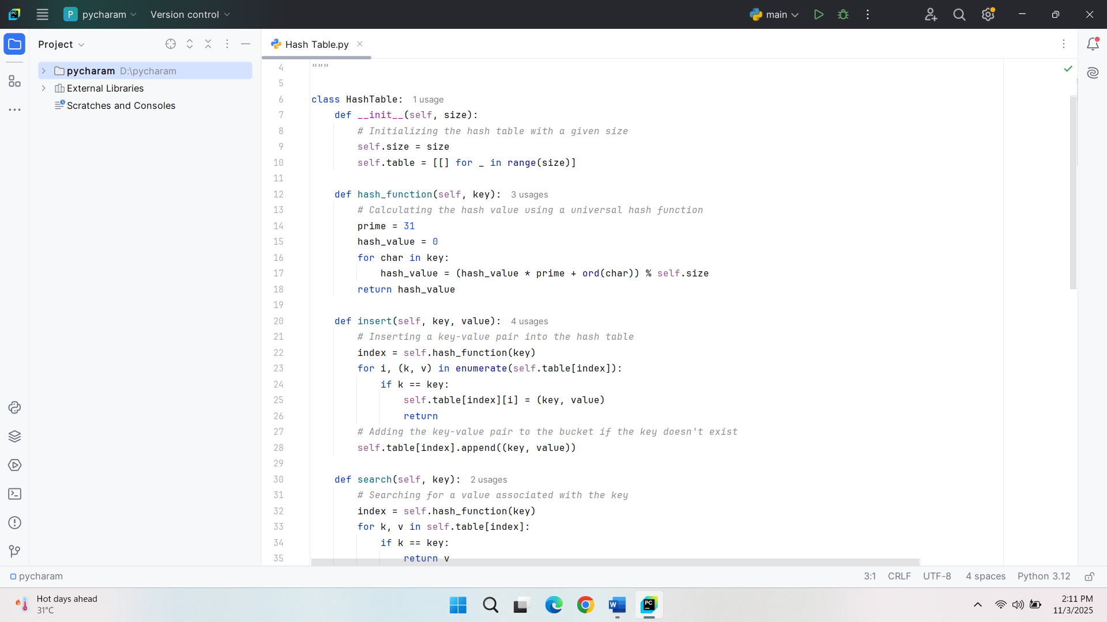
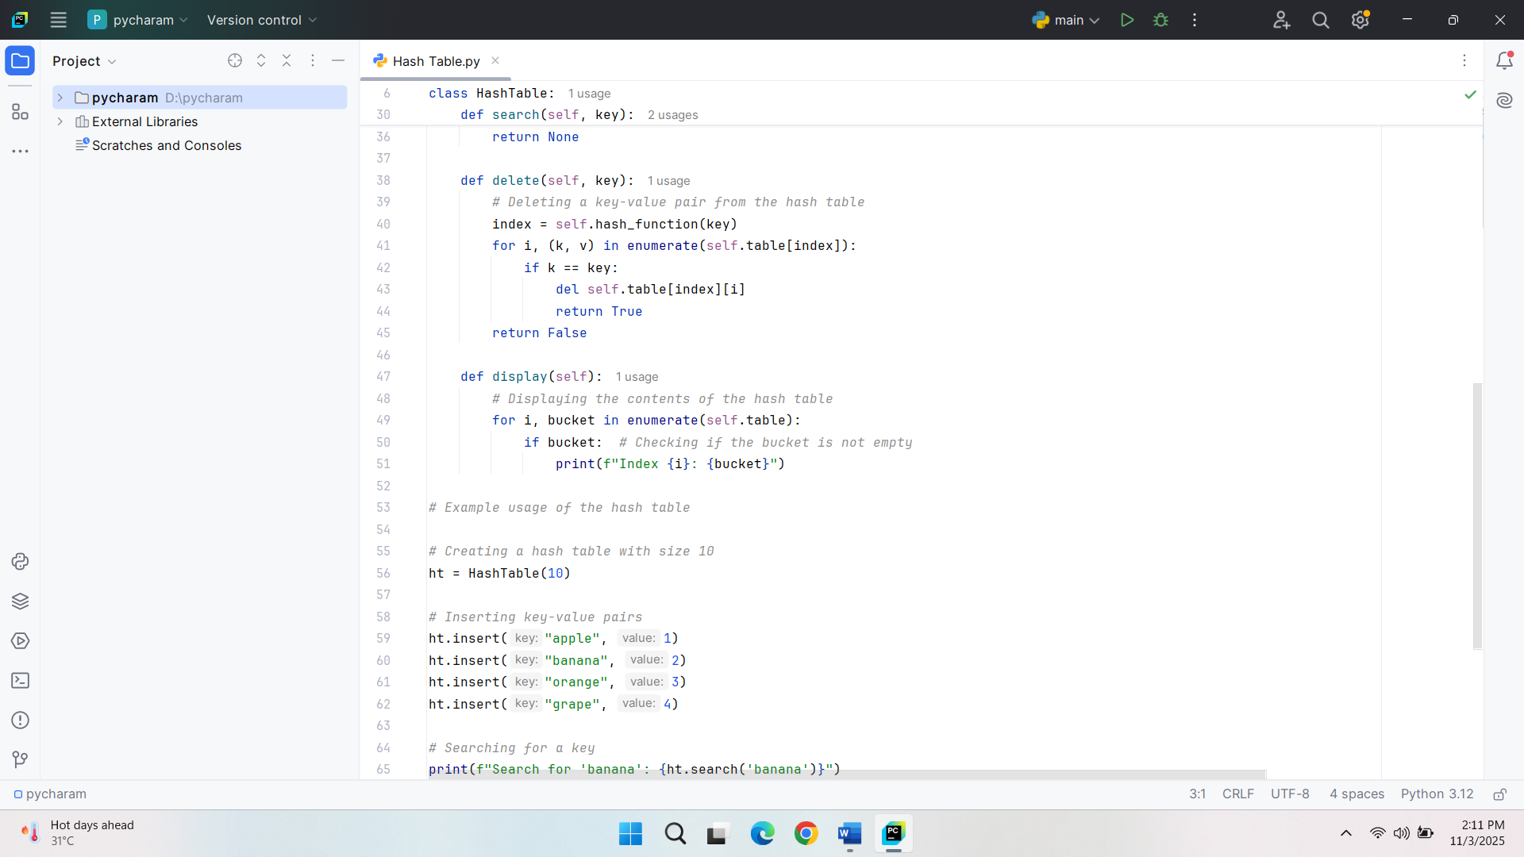
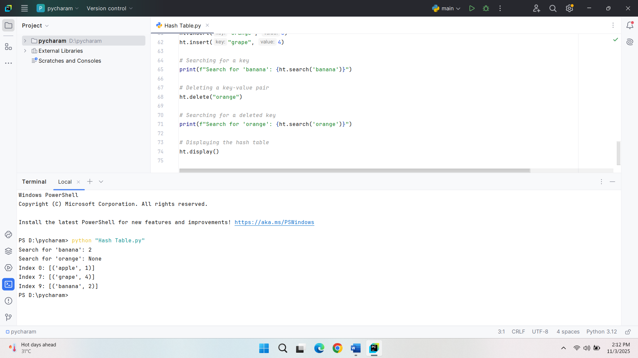
Simple Uniform Hashing Probable Search, Insert, and Delete Times
In simple uniform hashing, the probability of any key in the hash table being hashed to a specific slot of the hash table is equal. In this ideal scenario of events, the average items per bucket are predetermined. Suppose there are n elements in a hash table and m slots, the potential number of elements in each bucket will be n/m. Given that collisions are resolved by chaining, the search, add, and delete operation time complexities are expected to be dependent on the number of elements in the corresponding bucket. The average time of each of these operations will be O(1 + α) time, where α is the load factor. The load factor a is given as n/m, which is the mean number of elements in a bucket (Wu et al., 2021). These operations do take time, in the best case, of O(1) time when the load factor is small. Nevertheless, steeper loads cause the time to take each operation to rise linearly with the length of the chains in the buckets and reach O(n) in the worst case.
Effect of Load Factor on Performance
Search, insert, and delete operations in a hash table are proportional to the load factor. When the load factor is higher, more elements are stored in every bucket, and chains are longer and more comparisons are made with each operation. It makes the operations more complex in time, particularly search, insert, and delete. In the case of a big load factor, the efficiency of the hash table decreases since the operations will take more linear time. Ideally, a low load factor means that most of the operations might take the same time, and hence the hash table is efficient. Thus, load factor is an important factor to control the performance of a hash table.
Low Load Factor Strategies and Reduction of Collisions
Several actions can be undertaken to guarantee a low load factor and lower collisions, the most common is dynamically resizing the hash table. Once the load factor exceeds a given limit, it is possible to re-allocate the hash table, adding more slots to it, which usually doubles the capacity. Once the size is changed, the hash table is rehashed, which reassigns the elements that are already in the old slots to the new slots, which assists in decreasing the number of elements in the bucket and in reducing the collisions (Yusuf et al., 2021). The scaling process ensures that the load factor is maintained to a minimum, which enhances search, insert, and delete operations. Also, a more advanced hash algorithm can be used to reduce collisions as a result of better dispersal of keys in the table, which again contributes to a higher performance.
Conclusion
Randomized Quicksort analysis has shown that the algorithm has an average time complexity of O(nlogn), which is efficient, particularly when working with sorted or reverse-sorted data, in comparison with Deterministic Quicksort. The observed empirical findings support the theoretical benefits of random pivot selection with regard to the prevention of worst-case performance. In the case of hashing with chaining, a low load factor can be maintained by various methods, such as dynamic resizing and effective hashing functions, in order to provide optimal performance of search, insert, and delete operations. These are strategies necessary for the realization of scalability and efficiency in practice.

References
Mohammadagha, M. (2025). Hybridization and Optimization Modeling, Analysis, and Comparative Study of Sorting Algorithms: Adaptive Techniques, Parallelization, for Mergesort, Heapsort, Quicksort, Insertion Sort, Selection Sort, and Bubble Sort.
Wu, Y., Liu, Z., Yu, X., Gui, J., Gan, H., Han, Y., ... & Yang, T. (2021, August). Mapembed: Perfect hashing with high load factor and fast update. In Proceedings of the 27th ACM SIGKDD Conference on Knowledge Discovery & Data Mining (pp. 1863-1872).
Yusuf, A. D., Abdullahi, S., Boukar, M. M., & Yusuf, S. I. (2021). Collision resolution techniques in hash table: a review. International Journal of Advanced Computer Science and Applications, 12(9).

